Adityaprava Sen

CSE 2nd Year

Roll-56

Assignment on Packages and Modules(outputs)

Q1-4.

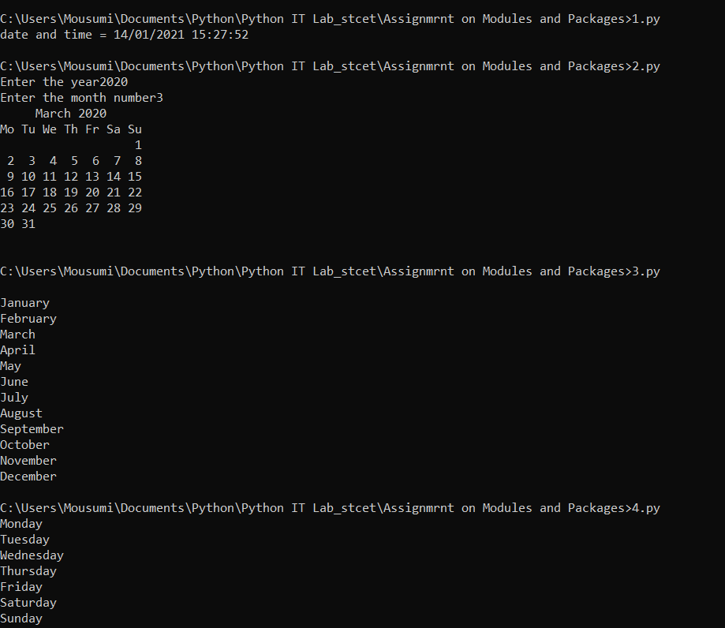

Q5-6.

